Example2

Example3

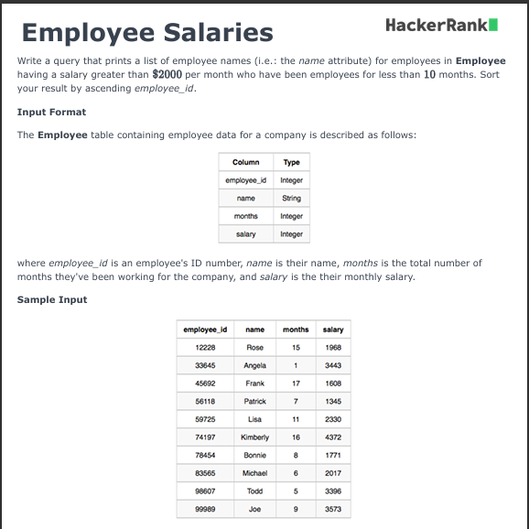

Example4

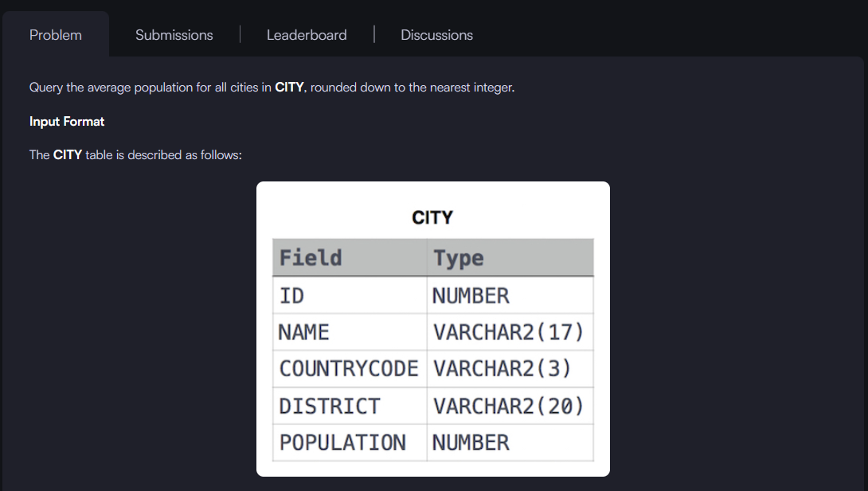

Example5

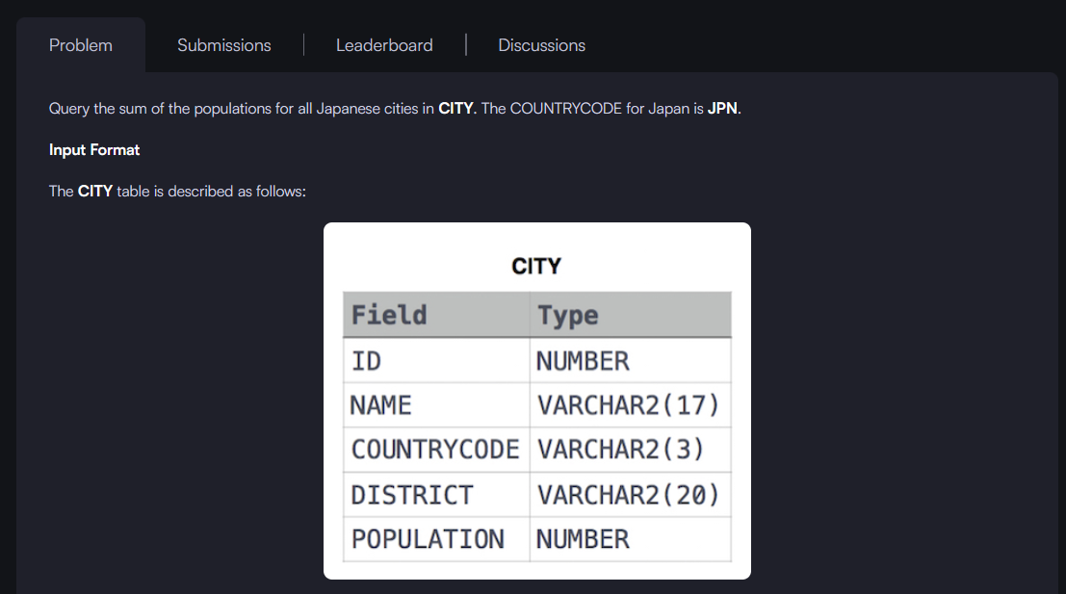



Example6



